**Project 2**

**Sustainable Supply Chain Performance Dashboard in Power BI**

**Introduction-** In this project, we are doing data analysis for Sustainable Supply Chain Performance using the Power BI Dashboard and now we make documentation, how Power BI performed over data and how to used it.

**Key Points-**

What is the concept of ETL?

ETL stands for Extracts Transform & Load.

* Extract- It means to extract or pull data from the source file such as- excel, csv, text, database file.
* Transform- It means to process the data or be cleaning.
* Load- It means to Load data into Power BI dashboard.

**Steps for installing the Power BI-**

1. Simply go to official Microsoft website or write download Power BI dashboard for windows and download it. (<https://www.microsoft.com/en-us/download/details.aspx?id=58494>)
2. Simply follow some instruction and open it and you will see the window looked like-

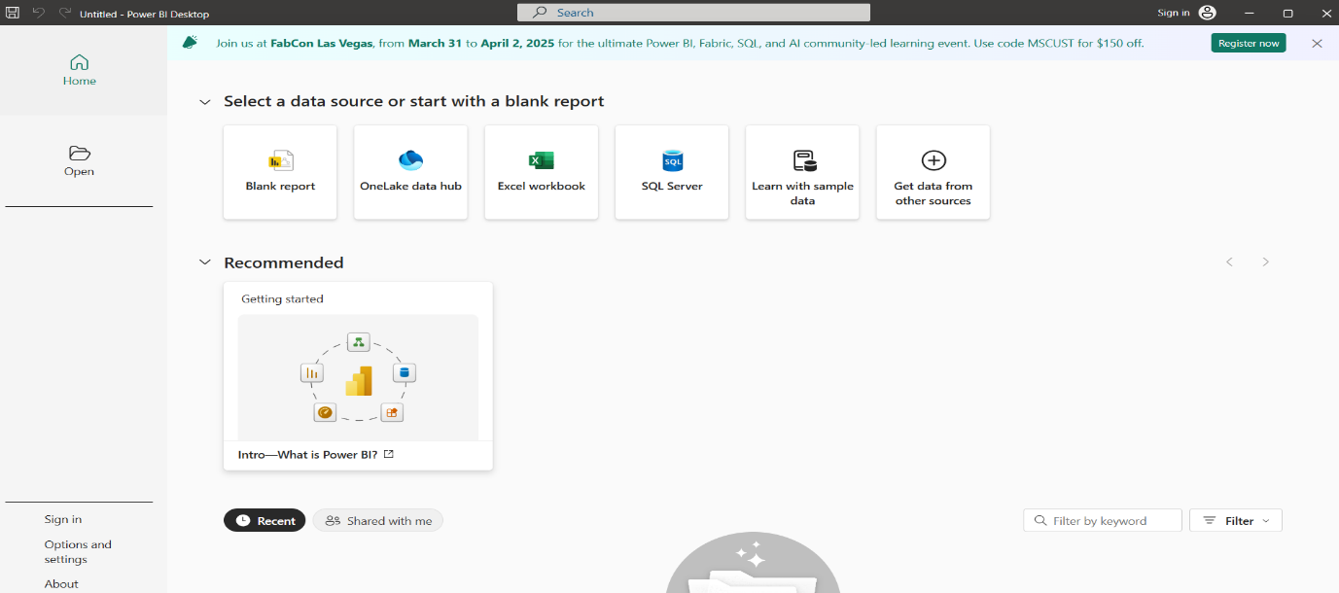

1. Now simply click on the Blank Report and open it and the window called as Power BI Dashboard window.

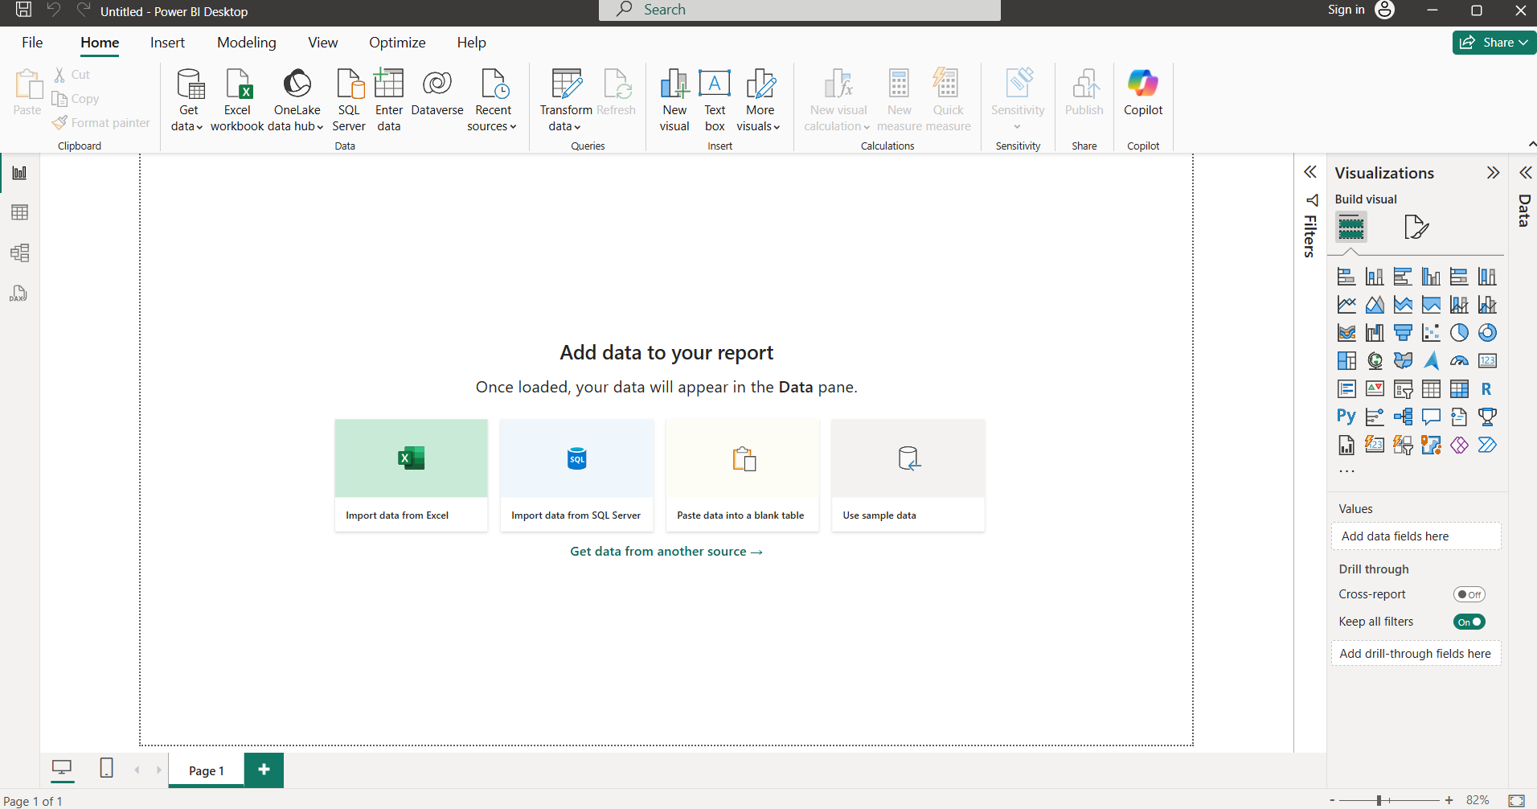

1. On the right-hand side- we can see different type of chart for building the dashboard and the central window called as canvas where we build these chart
2. Now you have extract data by the help of Get data and you can get data in different form such as- SQL server, web, text, csv (comma separated values), etc.

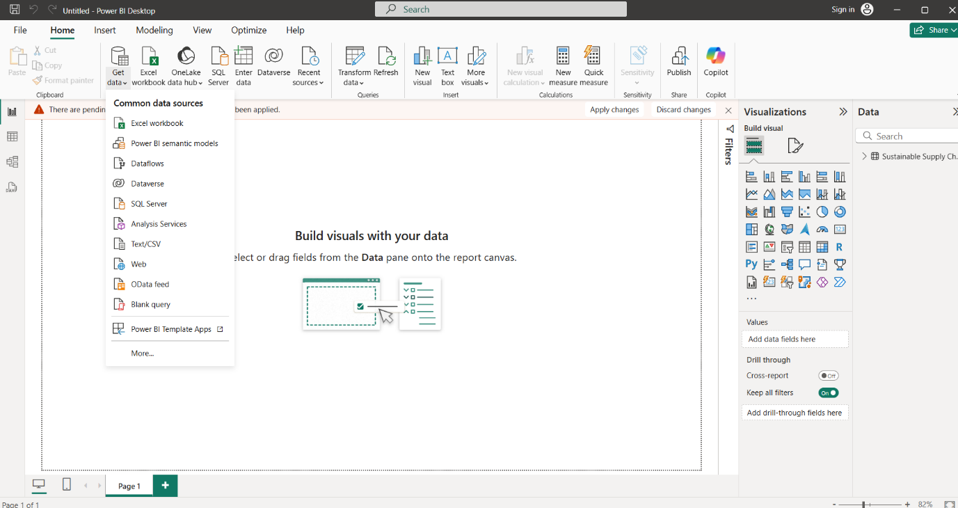

1. Now you have to transform the data and check the data is cleaned or not.
2. Hence, you have to load the data and working on it.

**Steps for working the Power BI-**

1. When to extract the data and load it data, then you can also perform a transform the data as well. Simply click on transform data and you have seen a new window called a Power Query Editor.
2. In Power Query Editor, you perform different things such as- choose columns, remove columns, choose rows, remove rows, merge query, etc.
3. When you click on view section, you can check the column quality which shows the column have valid, error, empty.
4. You can also see the datatype for the column, there may be different datatypes such as- decimal number, whole number, text, date, time, etc.
5. You can also make the duplicate of the table, by simple right click on table and select the option duplicate and then you can see the duplicate table on it.

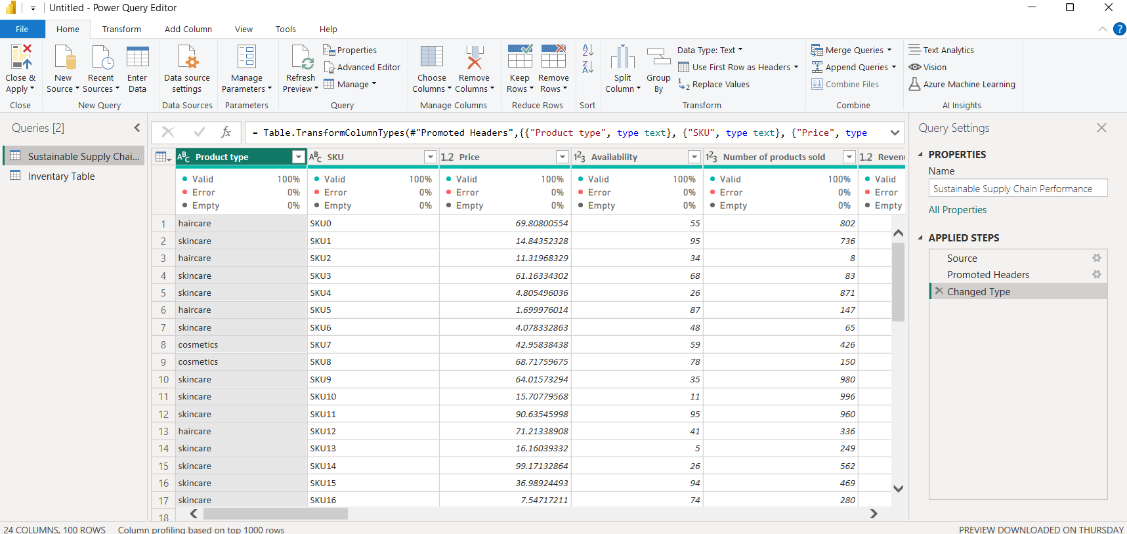

**Inventory Table-**

Steps for performing on Inventory table-

1. Now check the columns which required such as-

* Product Type
* SKU
* Availability
* Number of products sold
* Customer demographics
* Stock Levels
* Lead times
* Order quantities
* Lead time
* Revenue generated

1. Remove the columns which is not required, by simply click on it and then right click and select the remove rows option or you can select multiple columns by simply press ctrl and select the column not required.
2. Therefore, we create an Inventory Table.

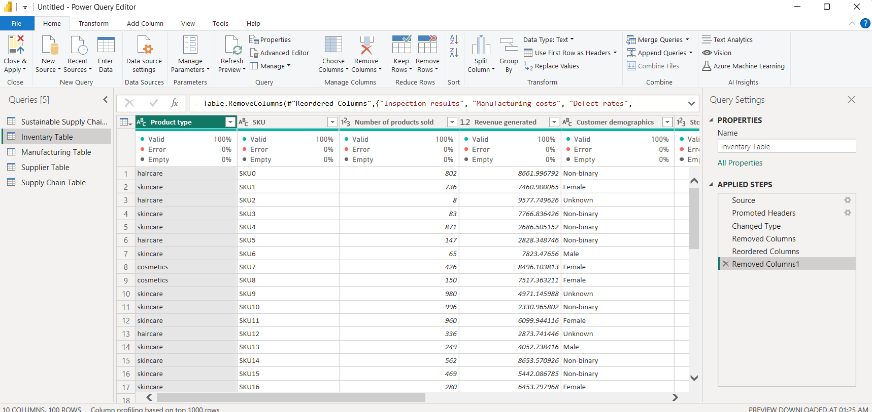

**Manufacturing Table-**

Steps for performing on Manufacturing table-

1. Now check the columns which required such as-

* Product Type
* SKU
* Production volumes
* Manufacturing lead time
* Manufacturing costs
* Inspection results
* Defect rates

1. Remove the columns which is not required, by simply click on it and then right click and select the remove rows option or you can select multiple columns by simply press ctrl and select the column not required.
2. Therefore, we create a Manufacturing Table.

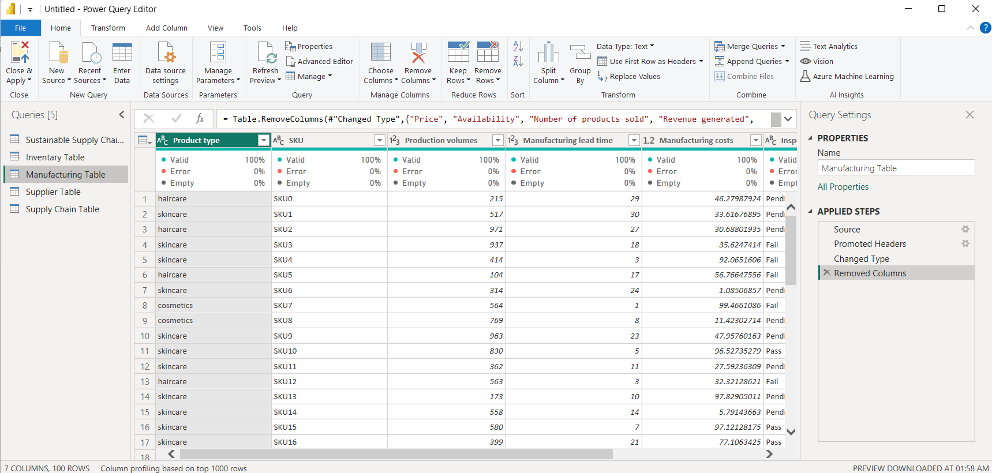

**Supplier Table-**

Steps for performing on Supplier table-

1. Now check the columns which required such as-

* Supplier name
* Location
* Lead time
* Transportation modes
* Routes

1. Remove the columns which is not required, by simply click on it and then right click and select the remove rows option or you can select multiple columns by simply press ctrl and select the column not required.
2. Therefore, we create a Supplier Table.

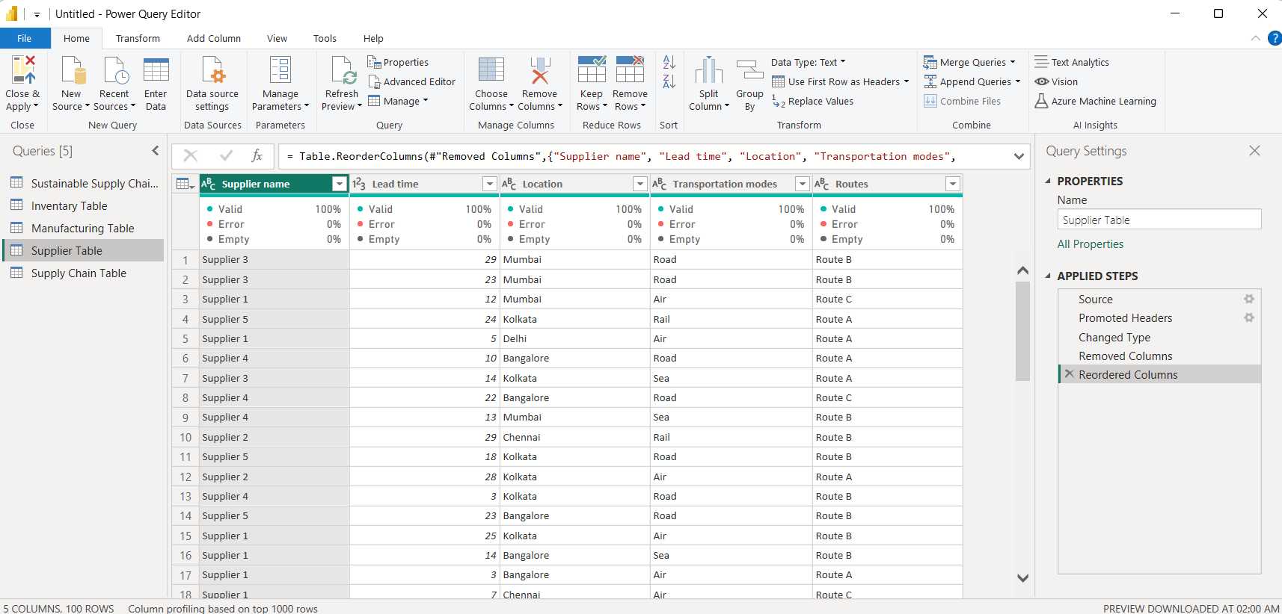

**Supply chain Table-**

Steps for performing on Supply chain table-

1. Now check the columns which required such as-

* Product Type
* SKU
* Price
* Availability
* Number of products sold
* Revenue generated
* Customer demographics
* Stock Levels
* Lead times
* Order quantities
* Shipping times
* Shipping carriers
* Shipping costs
* Supplier name
* Location
* Lead time
* Transportation modes
* Routes

1. Remove the columns which is not required, by simply click on it and then right click and select the remove rows option or you can select multiple columns by simply press ctrl and select the column not required.
2. Therefore, we create a Supply chain Table.

